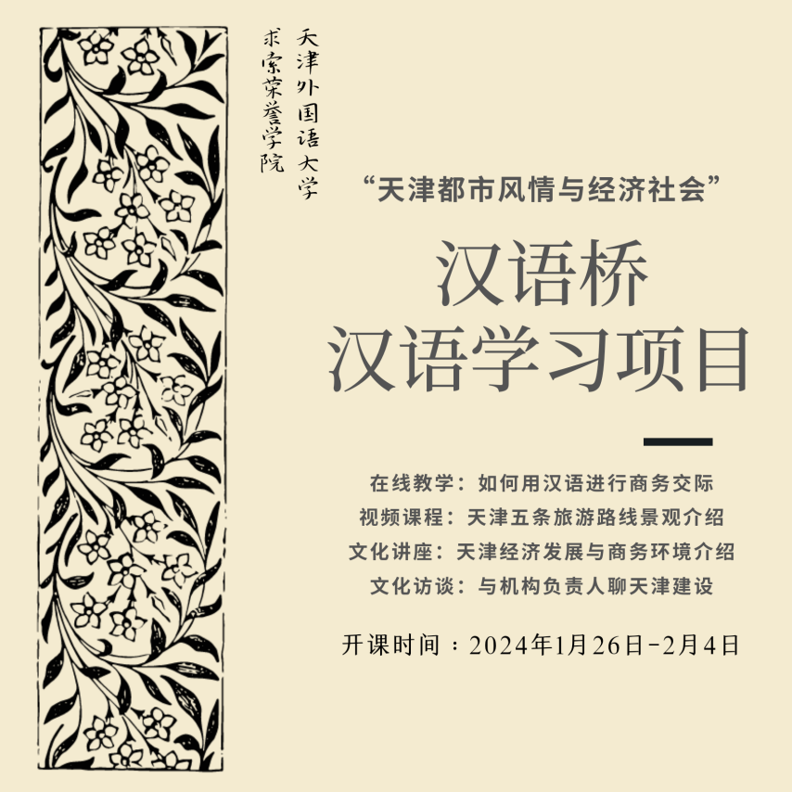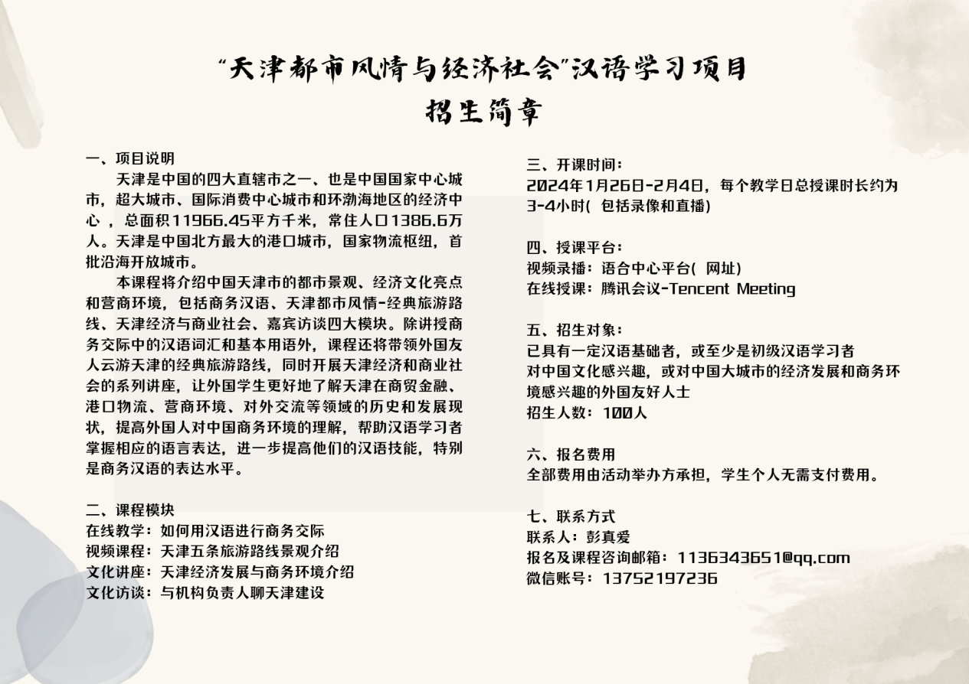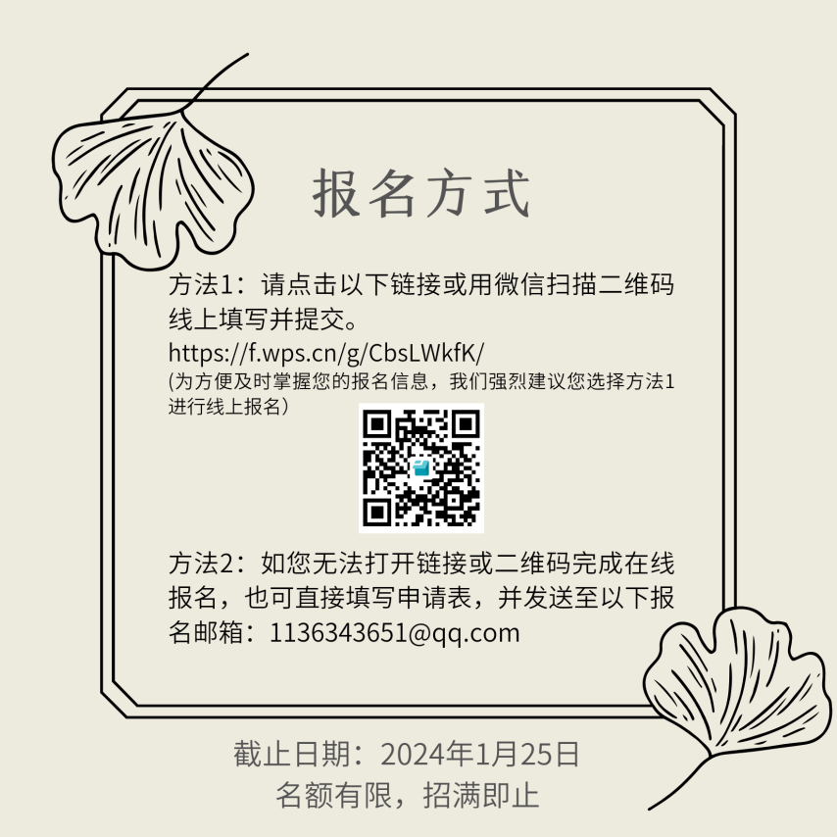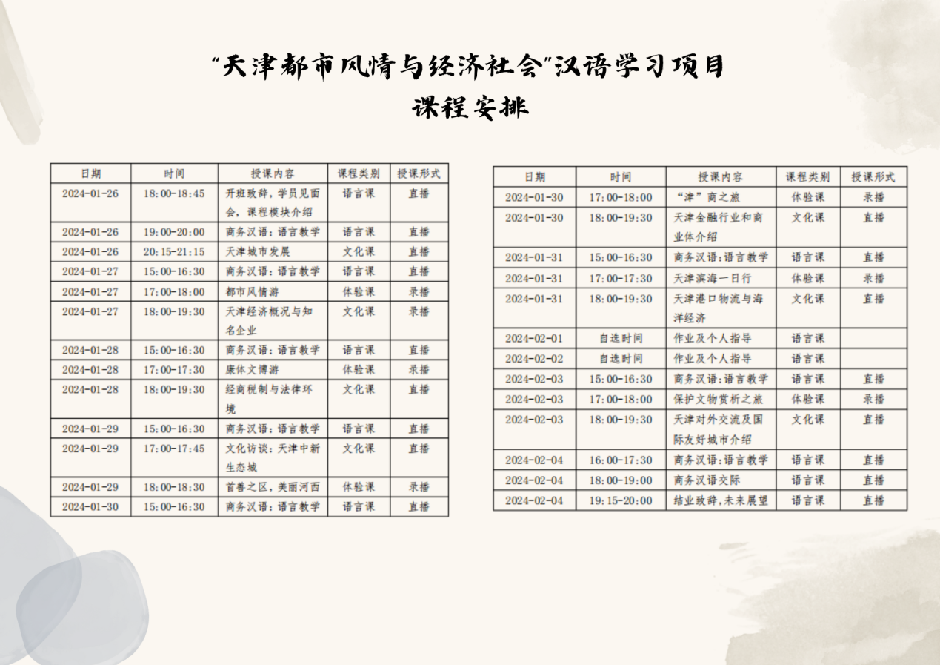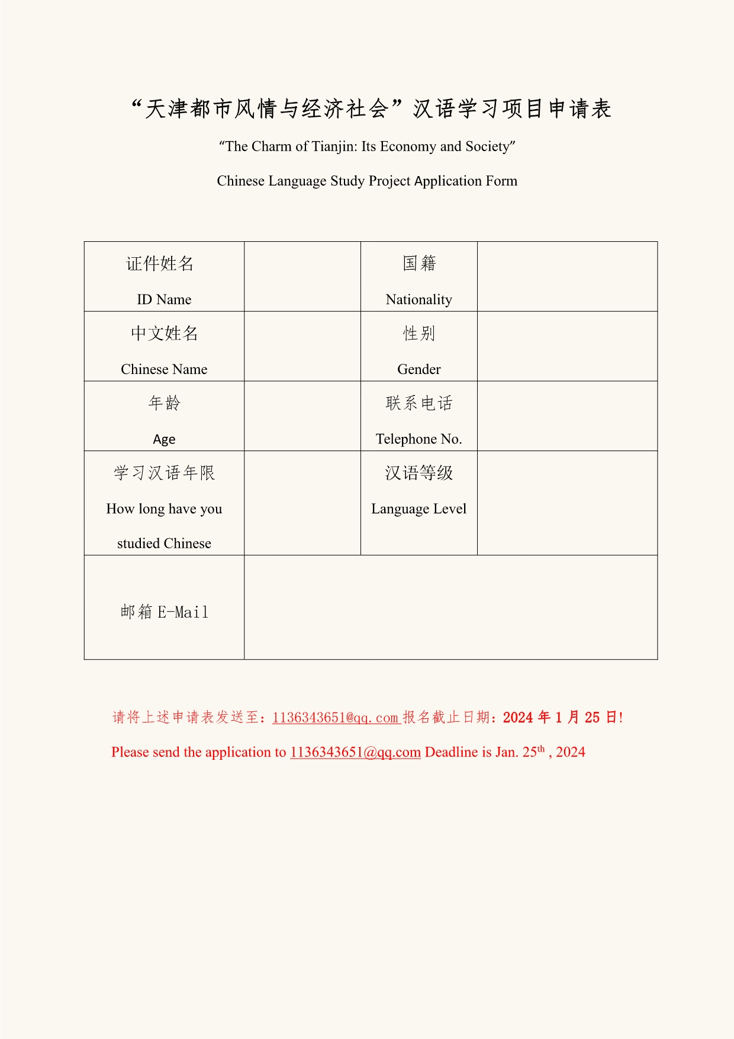

**“天津都市风情与经济社会”汉语学习项目申请表**

“The Charm of Tianjin: Its Economy and Society”

Chinese Language Study Project Application Form

|  |  |  |  |
| --- | --- | --- | --- |
| 证件姓名  ID Name |  | 国籍  Nationality |  |
| 中文姓名  Chinese Name |  | 性别  Gender |  |
| 年龄  Age |  | 联系电话  Telephone No. |  |
| 学习汉语年限  How long have you studied Chinese |  | 汉语等级  Language Level |  |
| 邮箱E-Mail |  | | |

请将上述申请表发送至：[1136343651@qq.com](mailto:1136343651@qq.com)报名截止日期：**2024年1月25日**! Please send the application to [1136343651@qq.com](mailto:1136343651@qq.com) Deadline is Jan. 25th , 2024